Socomec’s Energy Storage Solution in REIDS

Singapore, October 29th, 2018
Socomec’s energy storage solution participates in the Nanyang Technological University, Singapore’s (NTU Singapore) Renewable Energy Integration Demonstrator Singapore (REIDS) on the offshore island of Semakau Landfill.

NTU’s REIDS initiative - largest microgrid R&D platform in Southeast Asia
Launched in 2016 by NTU, the REIDS initiative is the largest offshore hybrid microgrid test and research platform in the tropics. It is built on Semakau landfill, located 8 km south of Singapore and serves as a model for the planning, deployment, and operation of physical microgrids. This clean-energy investment bodes well for Singapore's role as the springboard for companies to serve the fast-growing markets in Asia. REIDS is supported by the Economic Development Board (EDB) and National Environment Agency (NEA).
Operated by NTU scientists alongside other industry partners, the research conducted at REIDS demonstrates how microgrids can produce stable and consistent power in the megawatt (MW) range, suitable for small islands, isolated villages, and emergency power supplies. Countries such as Indonesia (17,500 islands), and Philippines (7,000 islands) have major challenges to provide electricity to communities living on remote islands. The project is intended to facilitate the development and market penetration of the energy technologies, suited for tropical conditions.
NTU has subsequently inked a partnership with French electricity provider, Electricité De France (EDF), to commence their project MASERA which focuses on EDF’s operating scope.

An exciting journey for Socomec
During the operation phase, REIDS Project wants to attain two main strategies for Excellence:
- Microgrid system demonstration and equipment testing
- Outreach program – engineering support, seminars, presentations & publications.
Socomec’s contribution to this project focuses on the Energy Storage solution. We provided through NTU’s partners, EDF and ENEDIS, a full energy storage solution that is capable of providing electricity to remote areas while reducing the cost of building a new electrical grid. Furthermore, Socomec provide expert technical support to our customers in the optimization and management of the system.

Installed on the Semakau the project encompassed power converters, batteries, AC/DC protection, Islanding management system, software …
This innovative storage solution, coupled with a full renewable energy system or hybrid sources (PV + Generator), is able to wholly supply isolated sites as rural or island areas, and can be extend to Commercial/Industrial Smart Buildings.
Designed for hybrid microgrids, the Socomec storage system is ideal for the electrification of rural or island areas. Indeed, Socomec’s system gives you the control of your installation, wherever you are, thanks to our easy to handle remote program and the autonomous management of main grid’s connection/disconnection. This means there is no need to invest on many subsystems, everything is in a compact and smart solution.

A forward looking Energy Storage business for the future
"Socomec's professional expertise in the control of low voltage energy conversion has been demonstrated through the innovative ENEDIS Projects, the European Nice Grid and Nice Smart Valley pilots," said Gilles ROCCHIA, Innovation Marketing Director of Socomec Energy Storage Business Unit. "The invaluable experience gained is the key motivation that keeps us going for these wonderful adventures together with our partners. Singapore is a choice location for companies to innovate and commercialize technologies. We aim to be a specialist in this field and continue to bring new technologies that optimize grid control and management while at the same time improve the quality of life of the less privileged”.
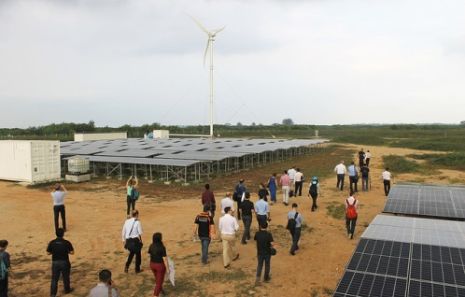
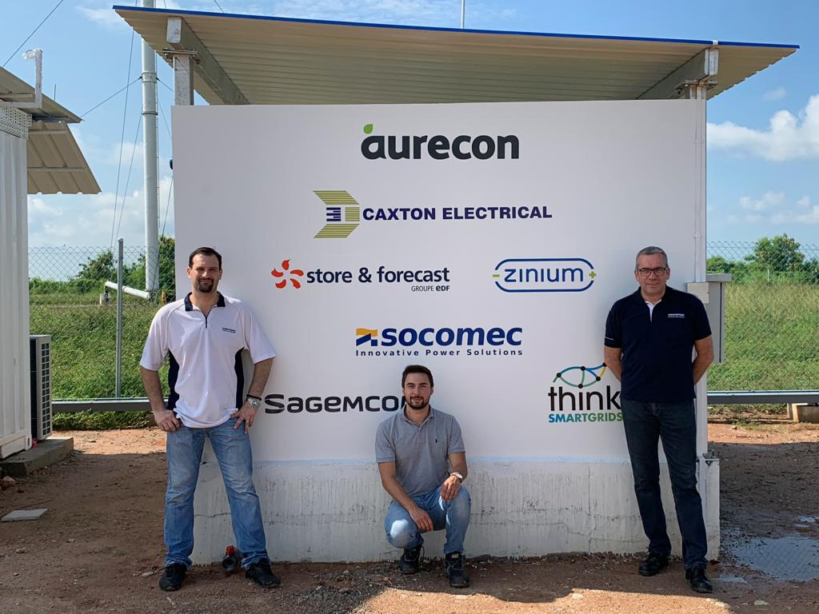
Left to right: Socomec’s Cedrick Petitpas, Alexandre Casalanguida and Giovanny Diquerreau.

More information about Socomec’s Energy Storage Solution: https://www.socomec.com/energy-storage_en.html

ABOUT SOCOMEC |  | MORE INFORMATION
Founded in 1922, SOCOMEC is an independent, industrial group with a workforce of 3200 people spread over 27 subsidiaries in the world. Our core business – the availability, control and safety of low voltage electrical networks with increased focus on our customers’ power performance. In 2017, SOCOMEC posted a turnover of 505M€. |  | Press contact  Gilles ROCCHIA  Innovation Marketing Director  Tel: +33 3 88 57 77 87  Email: gilles.rocchia@socomec.com  www.socomec.com

