Power-Up: Socomec’s increased power factor delivers 12 % more active power, in a proven and robust solution.

Benfeld, 2nd May 2017
Socomec’s DELPHYS MP Elite+, from 80 to 200 kVA, is now available with an increased power factor of PF0.9 - for 12 % more active power.

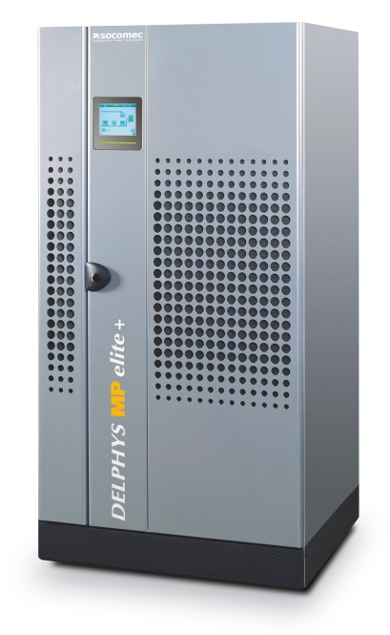
Integrated power specialist, Socomec, has extended its range of DELPHYS 3-phase UPS to deliver 12 % more active power.
PF 0.9
The transformer-based DELPHYS MP Elite+ - based on the proven DELPHYS technology and engineered for the most demanding electrical infrastructures - provides high quality power with maximum availability and total protection, throughout the equipment lifecycle.
Deployed in the most challenging environments around the world, this latest evolution has an increased power factor of PF0.9 and operates in VFI mode (online double conversion) to ensure total load protection for mission critical applications.
With high overload capability to withstand abnormal load conditions – and output voltage precision under all load conditions - the DELPHYS MP Elite+ has a very high short-circuit current capacity.

High quality power supply - now with 12 % more active power
An isolation transformer installed on the inverter output ensures complete galvanic isolation between the DC circuit and load output - this insulation also provides a separation between the two inputs when they are supplied by different sources.
The system has been specifically engineered to minimize constraints on the upstream power supply.
The “clean” IGBT rectifier, drawing sinusoidal current, is highly efficient and ideal for LV distribution networks. With a high and constant input power factor, and low THDi, the over-sizing of upstream power supply installations is avoided and power consumption - and associated costs - are reduced.
With increasing pressure on budgets within every facility, this compact system delivers a high power density, maximizing the return on valuable floorspace. It incorporates features to optimize your installation - the mains connection of the rectifier requires only three cables (no neutral) and the battery connection to the UPS only requires two cables. Furthermore, the high short-circuit capability simplifies downstream protective devices.

Availability - guaranteed
The Delphys MP Elite+ is based on robust technology utilized to protect critical power loads such as industrial processes, as well as other vital applications in healthcare, infrastructure or telecommunications. With IP protection adaptability, high fault current capability and long back-up time, the system has been designed to be adapted for a wide range of operating environments.
Mechanically and electrically robust, the system’s fault-tolerant architecture with in-built redundancy - such as the ventilation system – is ideal for high availability requirements.
Easy to maintain, MTTR is reduced as a result of easy to access sub-assemblies and components - minimizing costly downtime.
Accurate diagnostics guarantee the power supply to the load – with cascade failure prevention for parallel systems for high availability.
Christophe DORSCHNER, Site Marketing Manager, Socomec, comments: “In order to address the industry’s greatest challenges, we work hard to ensure that our product developments deliver reliable, high performance and cost-effective power solutions. Availability is guaranteed, as downtime is simply not an option. The latest evolution of our proven Delphys MP Elite product is now an even more powerful package - designed to meet the evolving demands of hard working electrical infrastructures today and tomorrow.”

Learn more about DELPHYS MP Elite+.

ABOUT SOCOMEC |  | MORE INFORMATION
Founded in 1922, SOCOMEC is an independent, industrial group with a workforce of 3100 people spread over 27 subsidiaries in the world. Our core business – the availability, control and safety of low voltage electrical networks with increased focus on our customers’ power performance. In 2016, SOCOMEC posted a turnover of 480 M€. |  | Press contact  Virginie GUYOT  Offer Communication Manager  Tel: +33 (0)3 88 57 78 15  Email: virginie.presse@socomec.com  www.socomec.com

