Socomec unveils a tempting offer for data centers

Benfeld, 30th September 2016
Service continuity, the safety of the power supply and the cost of energy are all critical issues for a data center.
The products and services offering from Socomec cover all these aspects and are suitable for all types of data centers, including new-build and retrofit projects with power supply requirements of 100 to 3000 kVA (i.e. premises covering approximately 100 m² up to 3000 m²).

Socomec, a recognised expert…
As a European and independent manufacturer with a worldwide presence, Socomec offers a range specifically adapted to data centers. Its products, solutions and services are targeted at fields of expertise recognised by its customers. Socomec solutions are already used in some of the world’s most renowned data centers.

…and a committed company.
As a signatory to the European Code of Conduct (CoC), Socomec has become actively involved in reducing the energy consumption of data centers via dedicated solutions with very high-output. Socomec is also a member of the European Data Centre Association (EUDCA) and of the Green GridSM, an association of companies in the IT sector that aims to promote energy performance for data centers.

The guarantee of high performance energy
For data center designers and operators, the stakes in terms of power supply performance can be summed up in five keywords: availability, efficiency, flexibility, capacity and durability. The Socomec solutions assure the continuity and safety of the site’s power supply, as well as guaranteeing maximum energy performance and cost-effectiveness throughout the life cycle of the installation. They also enable operators to adapt quickly to constantly evolving power demand and safety requirements.
By helping to optimise energy resources and costs, these solutions also allow the capacity of the data center’s existing electrical infrastructure to be maximised, delaying the need for power upgrades and hence extending the deadline for new investments. Finally, they showcase the results of an environmentally responsible approach.

Specifically, where do these solutions come in to play?
At the level of the physical infrastructure, the Green Power 2.0 UPS and the motorised or automatic Atys changeover switches assure the power supply to safety systems (fire, access control, etc.) and secure the supply to critical operating equipment (air-con systems, etc.), at the same time providing safety of persons and assets.

In the computer rooms, the same UPS in combination with the STATYS static transfer systems assure the continuity of service and protection of the IT equipment by providing high quality and reliable energy, this being monitored by the DIRIS Q800 network analyser.
In the control room, the UPS assure the power supply to monitoring equipment for the electrical, physical and computing infrastructure.
Installed at all levels of the electrical network, the DIRIS Digiware measurement and monitoring system and COUNTIS E energy meters enable the site’s overall energy efficiency to be maximised (via metering, multi-measurement and energy management, etc.).

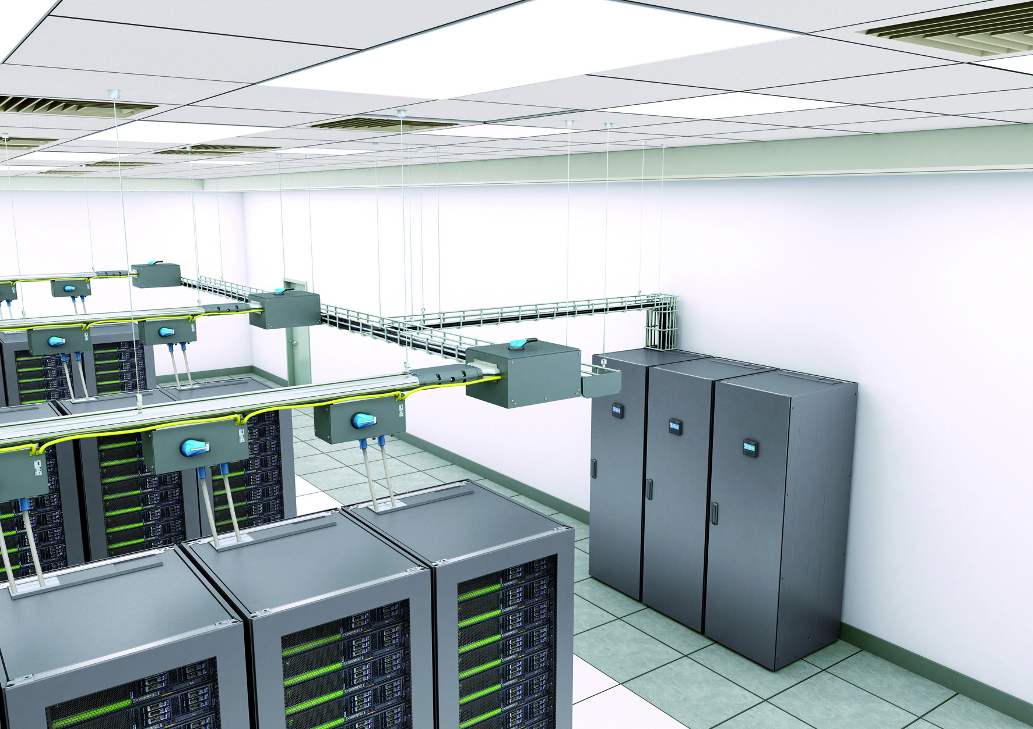
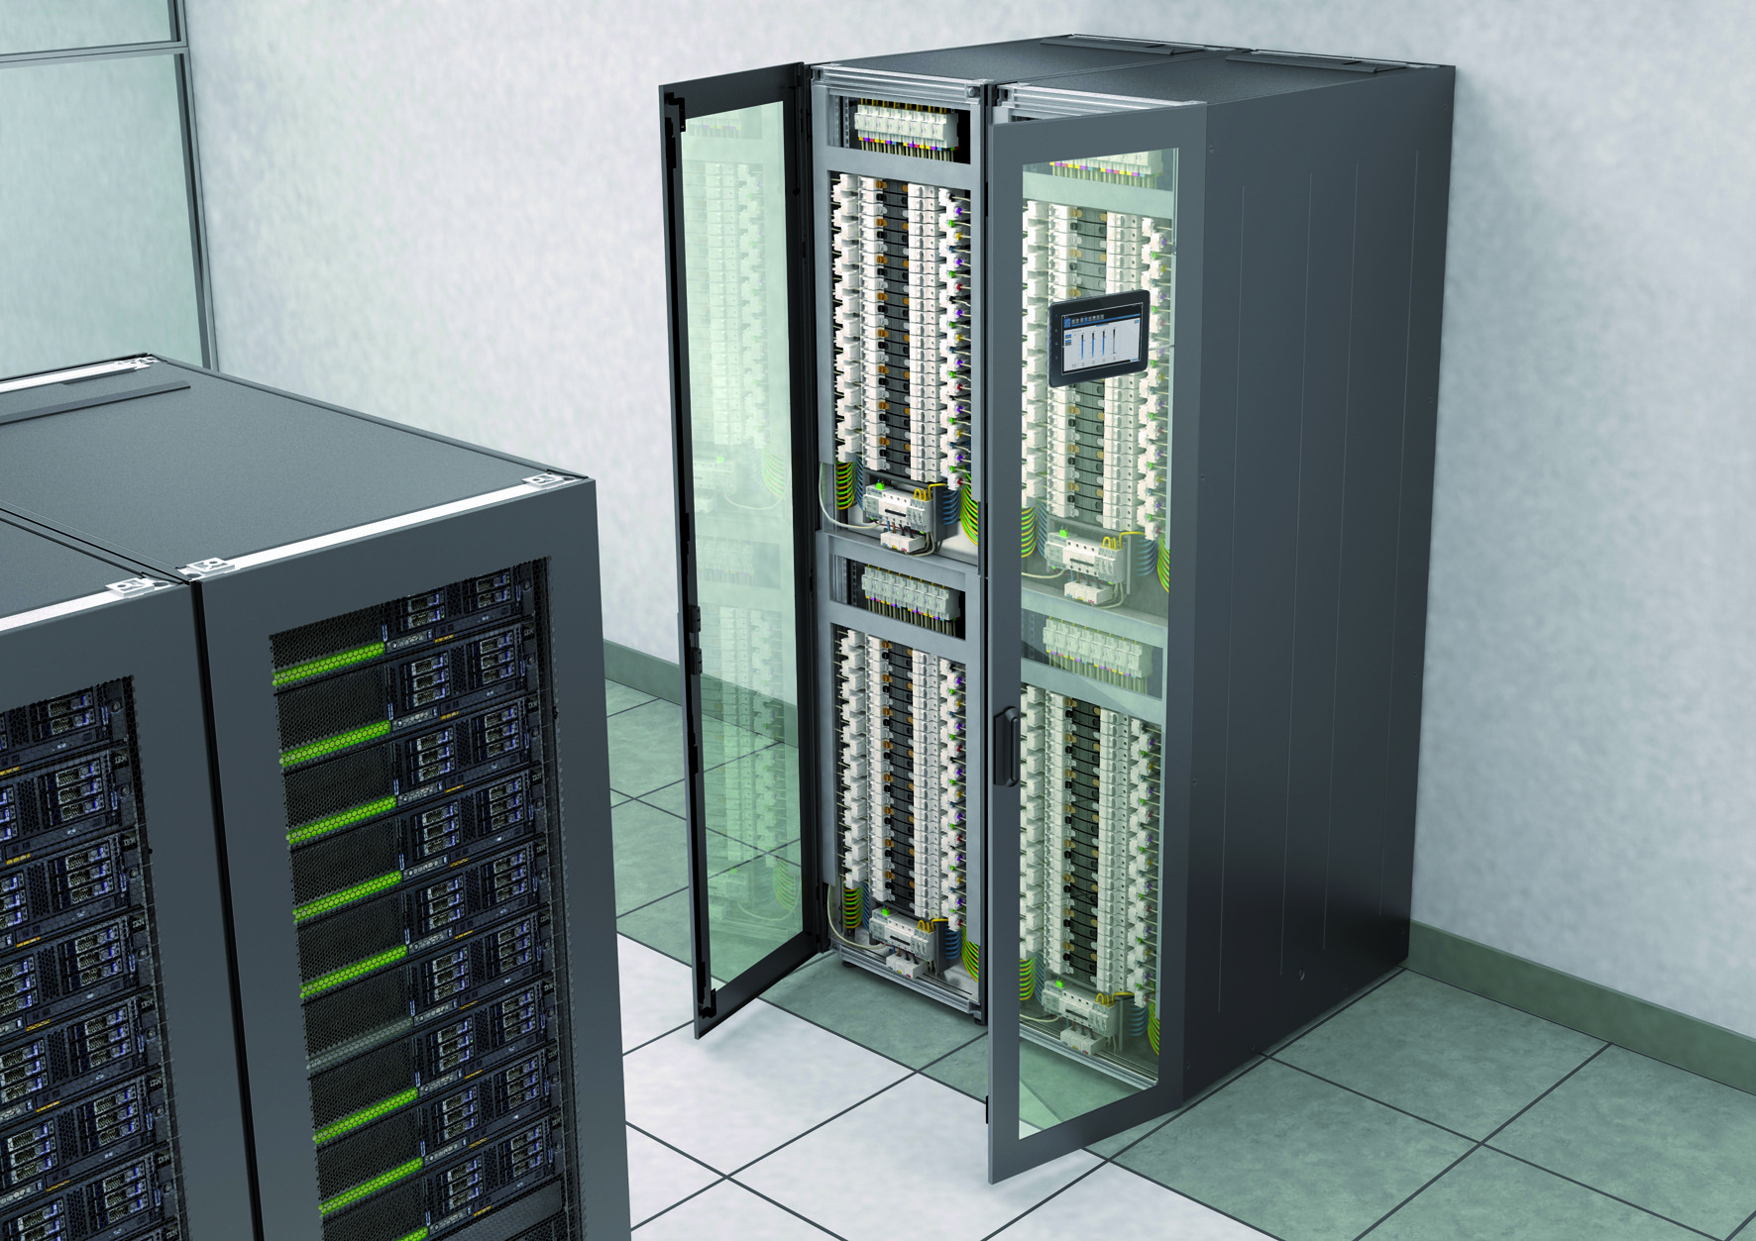

The services of an expert
PLUSSERVER AG is one of many examples of data centers for whom electrical energy performance and availability are as important as the quality of service provided by Socomec.
For Rémy Schweitzer, Site Manager at PLUSSERVER AG, “My priority is to have continuity of service for the data center. To achieve this we chose Socomec equipment (UPS and battery monitoring systems as well as the PLATINUM+ maintenance program), which is perfectly adapted to data centers.
Their teams were attentive, close to our site and available round the clock, as that was one of the options included in our contract. That meant I could work with full confidence. We have just finished our annual maintenance with specialists who have been assisting us in
this work for the last three years.”
With manufacturing plants and subsidiaries across the globe, over 370 Socomec specialists are at your service for your specific requirements, backed up by 175 engineers and technicians from our network of distributors.

The Socomec teams offer a wide range of services and personalised back-up: pre-project support (advice, technical audits, system definition, etc.), site development with guaranteed continuity of operation, commissioning, training, monitoring of site activity and maintenance, as well as equipment hire or a complete containerised solution.

To find out more: visit our website

ABOUT SOCOMEC |  | FOR MORE INFORMATION
Founded in 1922, SOCOMEC is an independent, industrial group with a workforce of 3000 people spread over 21 subsidiaries in the world. Our core business – the availability, control and safety of low voltage electrical networks with increased focus on our customers’ power performance. In 2015, SOCOMEC posted a turnover of 467 M€.  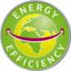 |  | Press contact:  Virginie GUYOT  Offer Communication Manager  Tel. : +33 (0)3 88 57 78 15  E-mail : virginie.presse@socomec.com  www.socomec.com

