SOCOMEC SCORES!
Socomec ATyS Bypass technology guarantees power availability at the home of rugby - Twickenham Stadium

Benfeld, September 15th, 2017
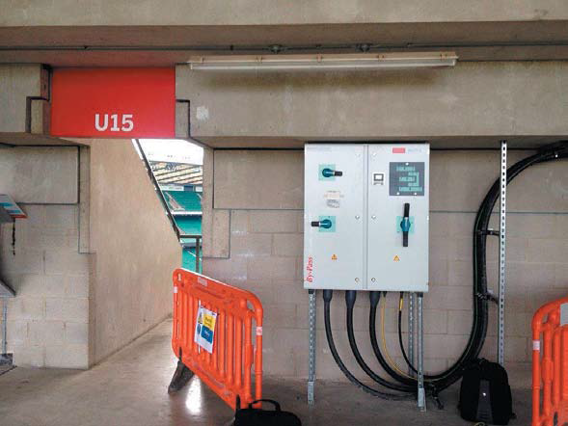
Socomec ATyS Bypass transfer switching technology systems guarantee power availability for stadium safety systems and essential broadcast equipment at the home of English rugby – Twickenham.
Twickenham Stadium is the largest dedicated rugby union venue in the world and has invested £75 million as part of a 25 year futureproofing programme.
Guaranteed power availability is an essential part of the program that will enhance the event experience for fans. Twickenham continues to exceed supporters’ expectations both on and off the field, whilst ensuring to improve operational efficiency.
Socomec products have been deployed around the stadium supplying various loads including lifts, pumps and control centres through Shepherd Engineering Services. S.E.S. is based in the UK and specialized in the design and installation of building services and other infrastructure solutions.
The ATyS Bypass is based on proven, third generation Socomec technology, these switching solutions are operating in extremely demanding environments worldwide and prove to be robust essential support to critical buildings and infrastructure. Working closely on this project with S.E.S., together we were successful in specifying the best-fit solution for the project’s unique power performance requirements.
The solution selected is Socomec ATyS Bypass switching technology that includes Automatic Transfer Switches. These are available from 40A to 3200A and combine ATyS Socomec Automatic Transfer Switching technology with a bypass system for maintenance. This means that any testing or inspection procedures can be carried out safely without interruption to the load. In other words, the system guarantees power availability to critical loads at all times.
Glenn Smith, Senior Project Engineer at S.E.S. Engineering comments; “Socomec’s ATyS system was selected in this application for its unparalleled reliability and cost effectiveness, as well as being an efficient solution in terms of space and energy efficiency. Commissioning was fast and efficient, supported by a highly professional and skilled Socomec team of expert engineers. This system provides the highest levels of protection for the stadium’s critical assets, infrastructure and people. It will ensure that supporters are safe and enjoy the best possible experience for years to come.”
Fully certified by the original manufacturer, Socomec’s products are designed as easy to commission and maintain whilst providing optimised performance throughout the equipment’s lifecycle.
More information about the ATyS Bypass on our website
ABOUT SOCOMEC |  | MORE INFORMATION
Founded in 1922, SOCOMEC is an independent, industrial group with a workforce of 3100 people spread over 27 subsidiaries in the world. Our core business – the availability, control and safety of low voltage electrical networks with increased focus on our customers’ power performance. In 2016, SOCOMEC posted a turnover of 480 M€. |  | Press contact  Virginie GUYOT  Offer Communication Manager  Tel: +33 (0)388577815  Email: virginie.press@socomec.com  www.socomec.com

