MODULYS GP “Green Power 2.0”: a new modular solution completes the Socomec Critical Power offering

Benfeld, September 2014

Privately owned European UPS manufacturer, Socomec, further strengthens its market-leading position with the launch of the new MODULYS GP solution.

A result of extensive engineering and in-depth analysis of customer needs, this 100% modular and fully redundant solution in the 50-600 kW power range completes the Green Power 2.0 family. The MODULYS GP Uninterruptible Power Supply (UPS) not only ensures the highest levels of power availability and scalability for critical IT infrastructure, but also provides the necessary margin for unforeseen evolutions in the design of secure infrastructure projects.

To meet the constantly evolving demands on energy performance within today’s IT infrastructures, this latest extension to the range has been designed around a system of redundant double conversion modules. The interconnected power and hot-swap battery modules means installation couldn’t be easier - as well as offering unbeatable flexibility for any future power demand upgrades. MODULYS GP is the result of Socomec’s 20 years of experience in providing modular solutions.

The architecture, incorporating an innovative “Forever Young” concept, combines a user-friendly system with the rapid implementation of many associated professional service packages. For example, maintenance operations can be carried out safely without interruption to the load. The system can also be upgraded at any point of its operational life cycle.

MODULYS GP integrates all the technological advances of Socomec’s Green Power 2.0 range, especially the optimum VFI output and unitary power factor that offers the highest power density currently on the market. The range maintains its benchmark position both in terms of its reduced footprint and energy savings.

The new MODULYS GP range has been developed and manufactured by the company’s centre of expertise in Italy and benefits from the latest advances in Socomec’s Lean production processes.

It is designed to operate in compliance with the EU Code of Conduct (CoC) governing data centres that aims to reduce energy consumption and carbon emissions.

Certification and verifications
- The output and performance levels of the MODULYS GP have been tested and verified by an independent body
- The first of its kind on the market, the MTBF value of the power modules has been certified as having the highest ranking on the market by an independent body (IEC 62380)
- The manufacturing site is ISO 9001:2008 and ISO 14000:2004 certified.

Key facts
- 100% modular and 100% redundant UPS, 100% SOCOMEC and 100% European
- No single point of failure
- System flexibility and scalability guaranteed during the service life of the IT infrastructure

Photo
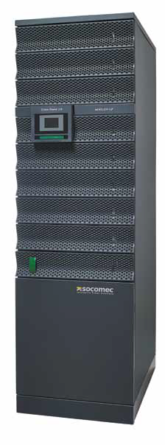

HD photos: click here
ABOUT SOCOMEC |  | FOR MORE INFORMATION
Founded in 1922, SOCOMEC is an industrial group with a workforce of over 3000 people around the world in 21 subsidiaries. Our core business: the availability, control and safety of low voltage electrical networks… with increased focus on our customers' power performance. In 2014, SOCOMEC posted turnover of 427 million euros. |  | Press contact: Virginie GUYOT  Offer Communication Manager  Tel. : +33 (0)3 88 57 78 15  E-Mail: virginie.guyot@socomec.com  www.socomec.com

