Socomec MEDSYS: an expertise in securing the availability of energy in healthcare facilities.

Benfeld, January 10th, 2018
In 2006, Socomec won an initial contract with the University Hospitals Trust of Strasbourg for a hospital bay at the New Civil Hospital, one of the Trust’s 6 hospital sites. As part of the project to build the new Medical Technology and Musculoskeletal Unit and the new Regional Cancer Institute at the Hautepierre site, Socomec supplied 39 equipped hospital bays to ensure continuity of power to operating theatres. In a hospital setting, it is critical that power to the operating rooms is continually available.

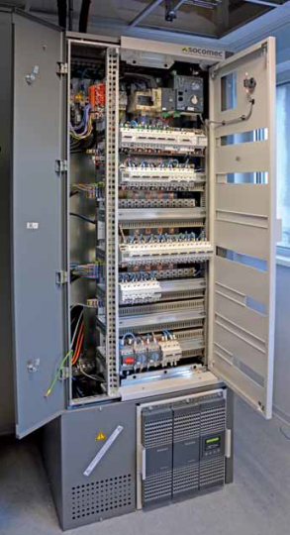
The solution was to use 39 MEDSYS 60 hospital bays made wholly by Socomec to equip the operating theatres of the new Medical Technology and Musculoskeletal Unit and the 2 angiography operating rooms.
The MEDSYS modular cabinet creates both a physical separation between the input and output wiring as well as a separation between low and high currents. It is equipped with a pivoting and reversible front panel, and fully extractable transformer and inverter compartments. The heart of the system is a culmination of “expert” functions:
- ISOM Insulation Monitoring Device, specific to hospital applications,
- NETYS UPS to ensure criticality level 1 without cut-off,
- ATyS transfer switch to ensure the redundancy between the double power supply upstream and the energy monitoring required by RT2012.

The connection is made by two IT neutral arrangements comprising a 10 kVA isolation transformer connected to an HMD 420 insulation monitoring device. If one of the sources fails, the UPS takes over when switching to the ATyS p transfer switch.
The MEDSYS 60 hospital bay is a 100 % Socomec manufacturer solution, from sheet metal to automatic transfer switch, right through to the electronic protection devices and UPS. This solution has been certified and tested according to the standard IEC 61439, which will soon be integrated into standard NFC 15-211.
The solution protects people against indirect contact. In an emergency, an emergency lever allows staff to control the device quickly, easily and safely.
This project is testimony to Socomec’s expertise in securing the availability of energy in healthcare facilities. Another example of the presence of Socomec in this field is Colmar Hospital, in the Haut-Rhin area, which is also equipped with MEDSYS bays.
More information on our website

ABOUT SOCOMEC |  | MORE INFORMATION
Founded in 1922, SOCOMEC is an independent, industrial group with a workforce of 3100 people spread over 27 subsidiaries in the world. Our core business – the availability, control and safety of low voltage electrical networks with increased focus on our customers’ power performance. In 2016, SOCOMEC posted a turnover of 480 M€. |  | Press contact  Virginie GUYOT  Offer Communication Manager  Tel: +33 (0)388577815  Email: virginie.press@socomec.com  www.socomec.com

